**Design module**

**What the design module is used for**  
The goal of the design module is to visualize map based data of the district and manipulate the data by applying measures on objects within the district.

**Visualizing data**  
Data is visualized by coloured objects like buildings based on properties of those buildings. Colouring is done through the use of a legend defined per visualized property or based on the definition of KPIs. KPIs are defined within the dashboard, not in the design module. All defined and processed KPIs are automatically available as a “Detail” item in the design module.

**Changing data**  
In the design module objects like buildings can be selected. Per project measures are defined that can be applied on specific objects or on the district as a whole. When applied on a set of selected objects these measures change values of properties of the selected objects. A second way of changing object properties is by means of a dialog where properties can be manipulated directly. Calculation modules can read these changed values and calculate KPIs based on those values. The KPIs that are related to objects can in turn be visualized by the design module. This chain of modules is controlled by the Ecodistrict dashboard.

**How to start the design module**The design module is started from within the Ecodistrict dashboard by clicking the “Open Design Module” button for “As-is”, see Figure 1, or by clicking the “Open Design Module” button in “Develop alternatives”, see Figure 2.

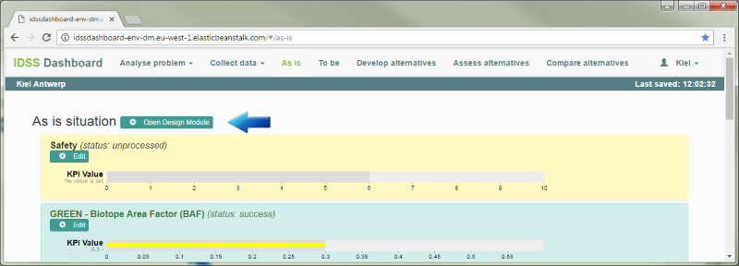

Figure 1, start the design module from the dashboard for the “As is” situation.

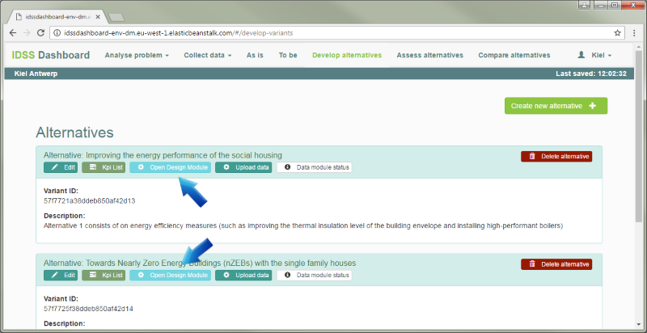

Figure 2, start the design module from the dashboard for an alternative.

**The design module**  
The user interface part of the design module is implemented as a web application. The central part is a map centred on the district.

**Control elements for visualization**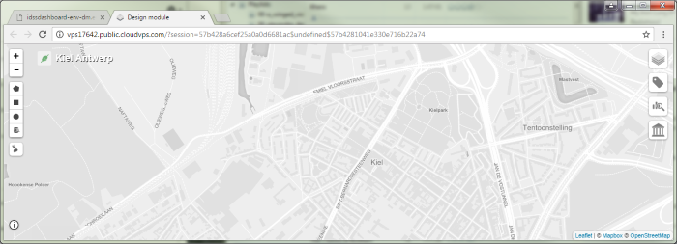

1. Map

Measures history

4. Select detail layers

3. Select domains

2. Base map/basic layers

Current project/alternative

1b. Zoom control

Show help

Select objects

Select measures

Figure 3, parts of the web application for control and visualizing data.

**1. Basic control of the map**

* Drag the map by pressing the left mouse button on an empty part of the map and then move the mouse. Release the mouse button to stop dragging.
* Zoom the map by selecting the “+” and “-“ zoom controls (Figure 3, option 1b) in the upper left corner on the centre of the map.
* Zoom the map by scrolling the mouse wheel on an empty part of the map (Figure 3, option 1). The map is zoomed at the current mouse location.

**2. Selecting what to show**Select the base map out of 3 options, see Figure 4, Figure 5 and Figure 6, from the Base map/basic layers control in the right upper corner.

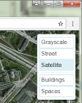

Figure 4, base map: Satellite.

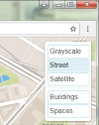

Figure 5, base map: Street.

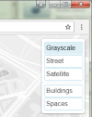

Figure 6, base map: Grayscale.

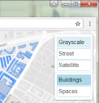

Figure 7, base layer: Buildings.

Besides the base map the basic object layers, see Figure 7, can be selected to be shown or hidden. In the example above basic objects “Buildings” and “Spaces” are available. All defined object types within the district can be shown as basic layers. They can be displayed on the map without specific colouring, just the outline of the objects for orientation and selecting objects. The Basic layers are coloured blue by default.

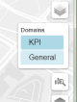**3. Domains**  
The set of properties that are available to be shown are grouped in domains. In the “Domains” control (Figure 3 option 3 and Figure 8) those groups can be enabled/disabled to filter the list of properties available in the details control below it. Deselecting items here reduces the number of items shown in the “Details” control (Figure 3 option 4 and Figure 9).

Figure 8, filter on domains.

**4. Details**  
Properties of objects can be displayed on the map. Colouring is done by predefined legends.

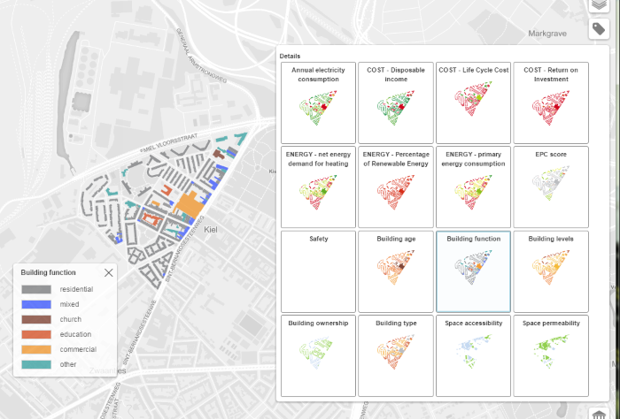

Figure 9, select “details” to show on the map.

In the above example “Building function” (Figure 9) is selected and overlaid on the map. The corresponding legend is shown on selecting an item but can be closed by selecting the cross in the upper right corner of the legend. The legend can be dragged to a different position. To make a closed legend visible: deselect and re-select a “Details” item.

**Applying measures to objects and changing object properties directly** 

3. Map

5. Measures history

Select detail layers

Select domains

1. Base map/basic layers

Current project/alternative

Zoom control

Show help

2. Select objects

4. Select measures

Figure 10, Parts of the web application to change data that the “details” are based on.

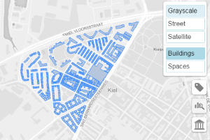**1. Basic layers**Basic layers can help with selecting objects. An enabled basic layer for buildings shows all known buildings in blue (Figure 11).

Figure 11, basic layer “Buildings” is shown on the map.

**2. Select objects**Objects can be selected in different ways:

* 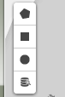drawing a polygon, rectangle or circle on the map (Figure 12): all intersecting and enclosed objects are selected. The selection mode can be chosen with the upper three icons in the left upper corner as shown here to the right.

Figure 12, select objects controls.

* based on values of their properties through a query build in an objects query dialog (Figure 13). This selection mode can be chosen with the lower icon from the set of 4 icons in the upper left corner as shown here on the right.

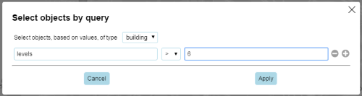

Figure 13, select objects by query dialog.

Selected objects are drawn in pink (Figure 14).

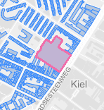**3. Select objects by clicking on the map**An object can also be selected by clicking the mouse on the map within or near an object (Figure 14). Enabling the corresponding “Basic layer” (Figure 11) helps locating objects. The first object selected determines the type of objects that can be added to the selection.

Figure 14, selected object on the map.

Any object defined in the project can be selected even if not visible. If the first object selected is a building for example additional buildings can be selected and deselected by holding down the CTRL key while clicking on or near a building object. Clicking away from any of the objects resets the selection.

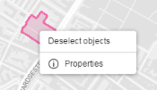**Right click on the map or on selected objects**A right click on the map or on a selected object shows a popup menu (Figure 15). The “Deselect objects” option is always available and will clear any previous selection. The “Properties” option is only available when the click was on one or more selected objects.

Figure 15, popup menu on a selected object.

**Edit properties of objects**

Right clicking selected objects shows a popup menu (Figure 15). Selecting “Properties” from that menu shows a dialog with common values for the selected objects (Figure 16). These values can be changed in this dialog and the changed values are applied into the database for all selected objects.

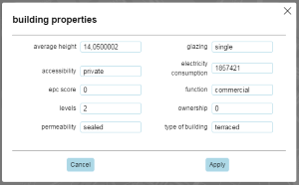

Figure 16, edit object properties dialog.

**4. Measures**  
In the Ecodistrict database measures are predefined per project and can be applied to selected objects or on the district as a whole. The measures available for the type of the selected objects are show when the “Measures” icon (Figure 10, option 4) is selected in the left upper corner. District wide measures are always shown.

Following is a set of measures available to be applied to buildings within the Antwerp case (Figure 17).

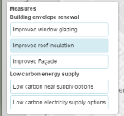

Figure 17, select a measure to be applied on previous selected objects.

Selecting a measure shows a dialog (Figure 18) with specific options for that measure.

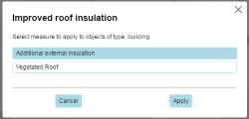

Figure 18, select an option for a selected measure.

When applied, that measure, including the selected objects, are stored under the “Measures history” control (Figure 10, option 5 and Figure 19) on the upper right side.

**5. Measures history/measures to be applied control**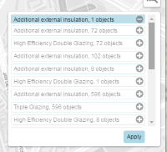

Figure 19, all measures, including previous applied measures, are listed to be applied to the database.

In this control (Figure 19) measures are collected to be applied en masse to the database. This control also gives an opportunity to re-use previous applied measures on other variants.

**Re-use the selection of measure objects**   
When a measure is selected (Figure 19) the corresponding objects that measure is to be applied to are selected on the map. This selection of objects can then be used to apply yet another measure.

**Re-apply measures from the history list**  
Measures applied to another alternative can be added to the active measures to be applied by selecting the “+” icon behind it (Figure 19). The “-” icon removes that measure from the active measures list.

**Examples**

**Workflow visualization of data**

* Start at the upper right corner.
* Select the base map you want to use. “Grayscale” keeps the focus on the coloured data, “Street” shows more information on the surroundings.
* Keep de basic layers switched of.
* Use the second icon in the upper right corner to select the domains of interest.
* Use the third “Details” icon to select a layer. A second layer can be selected with lower opacity on top of the first one by pressing and holding the CTRL key while selecting an item from “Details”. Selecting an already enabled item from “Details” while holding the CTRL key toggles that items visibility.

**Workflow changing data by applying a measure**

* Start at the upper right corner.
* Select the base map you want to use. “Grayscale” keeps the focus on the coloured data, “Street” shows more information on the surroundings.
* Select the basic layer of objects you want to apply measures to; This helps with selecting objects.
* Select a method of selecting objects on the upper left corner.
  + Select objects by using a polygon: draw a shape by settings the corners. Click the first point to close the shape. All objects touched by this shape will be selected. Holding down CTRL while closing the shape will add objects to any existing selection.
  + Select objects by drawing a rectangle. All objects touched by this rectangle will be selected. Holding down CTRL while drawing the rectangle will add objects to any existing selection.
  + Select objects by drawing a circle. All objects touched by this shape will be selected. Holding down CTRL while drawing the circle will add objects to any existing selection.
  + Select objects by executing a query on the database based on property values of the objects. All objects matching the selection criteria will be selected.
  + Just click in or near an object to select it. Holding down CTRL while clicking will toggle if the object selection.
* Select a measure at the upper left corner.
* If there are option defined with the measure a dialog will popup. Select the appropriate option and press Apply.
* The combination of the selected objects, measure and measure option will be added to the measure history on the upper right corner, 4th icon from the top.
* Repeat selecting objects and selecting measures.
* In the measures history enable and disable measures to apply to the database. Previous applied measures can also be re-applied.
* In the measures history press apply to changes the object properties in the database. The applied measures will be added to the history to be re-apply able in the future.